**Goal of Test:** we will test the Rotation of the map (Crossing).

**Description:**

User wants to rotate the crossing. The feature available is to rotate the crossing clockwise 90 degrees. User can click as many times as he wants and the map will be rotated 90 degrees by each click.

While the simulation is running and there is a crossing on the screen, user clicks on crossing to be selected then user clicks on icon on the menu bar to rotate the crossing.

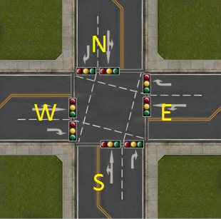 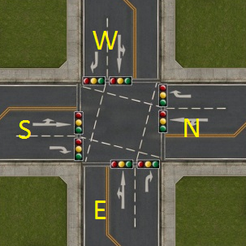

**Expected Result:**

The crossing will be rotated by each click, 90 degrees clockwise.

Possible Scenario:

User clicks on the rotation symbol but nothing happens.

|  |  |  |  |
| --- | --- | --- | --- |
| **Test Case** | **Method** | **Test result** | **Success?** |
| 1. Rotate crossing | 1-user clicks on the crossing  2-user click on the rotation icon  Possible scenario:  Nothing happens when users tries to rotate | System will rotate the crossing 90 degrees |  |

**Goal of Test:** Checking lane availability for the cars

#### **Description:**

This test will check the availability of a lane. As you can see in the picture, the yellow boxes are the cars that are having a queue between crossings. Each lane between crossings has a maximum number of cars which they can hold. So if there is a car which wants to go to that lane, the car must check if there is still a spot left for it to go there. If not then the car cannot go to that lane or they must wait to go there.

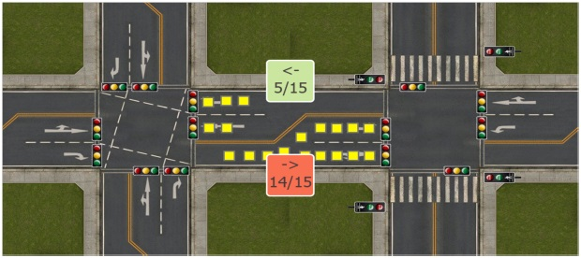

In this test, we will examine if the car can go to the next lane if, a free spot available on the lane ,

If not then what will happen.

Method:

The user start simulation, and add few cars on a lane, (there will be available spot on the lane).

User runs the simulation again.

**Result:**

The car successfully goes to the next lane while there is free spot on the lane.

**Possible scenario**:

1. The car will still go to the next lane while there is no free spot.
2. The car will wait even the traffic light is green, till the lane has free spot.

|  |  |  |  |
| --- | --- | --- | --- |
| **Test Case** | **Method** | **Test result** | **Success?** |
| 1. Lane availability | 1-user start simulation  2-user add few cars on different lanes  3-user runs (play) simulation again.  Possible scenario:  1-cars still go to next lane while there is no empty spot.  2-cars wait till the lane is free. | System moves a car to the next available lane. |  |